Fiona tells us much more about herself
I can’t remember ever not creating something. As a child my bemused parents would smile dutifully as I gave them the latest 100 or so Christmas ornaments I had just rustled up or ran in very excited to show them the new toy I had designed. The cardboard wrapping was always preferable to me to what was inside, and a big carboard box and some Sellotape? Endless possibilities. One year my Dad won a big Easter Egg, forget the chocolate, but the box? Well obviously, crying out to be made into a doll’s Cinderella’s coach, with that large oval cellophane window.
After a brief stint at Art College, and movement into the ‘real world’ of paid jobs, I would still find a way to veer to the creative side, whether window decorations for a retail shop or drawing covers for in house magazines. Free time, evenings and weekends always involved something creative, and by my mid 30’s I was extensively painting in oils, which I still do. My painting style is detailed and realistic, and for that you need not just time, but patience. I had successful painting exhibitions both in the UK and abroad while in full time employment, and painting seemed to suffice most of my creative urges, but not that ‘making’ with your hands that I still craved.
After an accident left me with a disability, I had to look for an alternative to mainstream work, and I moved further into the world of arts and crafts. I look at this time of my life with a positive attitude, if I hadn’t had the accident I would probably still be in mainstream work and be a stifled artist, so in many ways I have a lot to be thankful for. I tried several different artistic mediums, learning from each as I went, until I met Ange Smith who in 2006, introduced me to Polymer Clay, and the rest, as they say, is history.
I simply love Polymer Clay. It is so versatile, so hands on, so colourful, so able to be and do whatever you need or envision. Obviously with my painting background, cane work drew me in immediately. The thought that you could create a picture in a 3-dimensional format, and take slices, wow, that was incredible.
At the start I experimented on my own, using a few polymer books as a guide. I rushed through so many techniques, always learning so much from when I made a mistake, or things didn’t quite come out as planned. As I learnt so I was able to move from simple shapes and canes into more complex work.
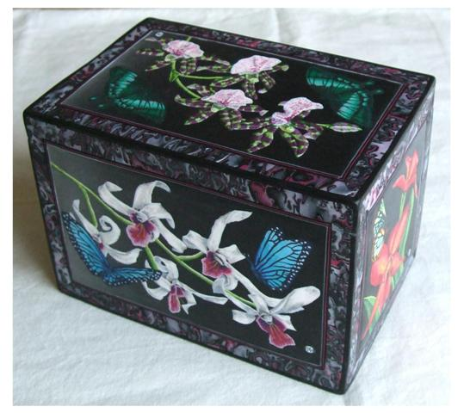
I went to the Midlands Polymer Clay Group with Ange and met some wonderful polymer artists there. My understanding and experience grew, and I realised the importance of attending workshops and how much I could learn from others’ experiences. Luckily Ange already attended the big workshops both in the UK and in France, and from then on, she took me with her. Oh, the bliss of being with scores of polymer enthusiasts, learning so many new things and making new friends.
Meeting Sue Heaser and learning about her Pietra Dura work was another eye opener, and a glimpse into several techniques I categorise as ‘Painting with clay’, something I am still experimenting with. I have made a couple of Pietra Dura boxes, completely from Polymer Clay, and each need a lot of patience, as they take well over 100 hours to complete.
Throughout my polymer journey I have learnt so many different techniques. I now sculpt with it too, and really enjoy being able to use cane work in my sculptural pieces, dragons, animals, fairy houses, flower sculptures. Even being a full-time artist, there are not enough hours in the day to create all the polymer ideas that flow through my brain.
I have had to learn some engineering skills, how to get the polymer to bake in all the complicated shapes I devise, how to support it, how to replicate what is in my mind in clay.
As you can tell, I am passionate about polymer clay.
I do however have a life outside of my art, I have a partner who I adore, and who is very supportive, albeit slightly exasperated with both me and my creations at times. We have been together for 33 years, and although, he did propose 32 years ago, and I said yes, we haven’t quite got around to the marriage yet, maybe one day.
Other than a loving family (I am very lucky in that) I do have 2 other major loves in my life, our Japanese Akitas. They are rather large dogs, (52kg) Kizzie our girl, and Yoshi our boy. We picked them up on the same day from different litters, and they are 3 days apart in age. I adore them, and I would have to say they do feature quite heavily in my dragon designs, both in the face, and in the poses. They are 10 now, so getting on a bit for older dogs, and Kizzie like me, limps badly, so we are a right pair when I take her for a short walk.
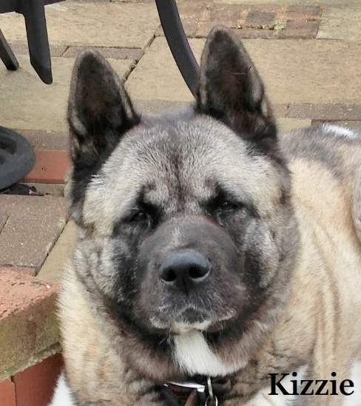

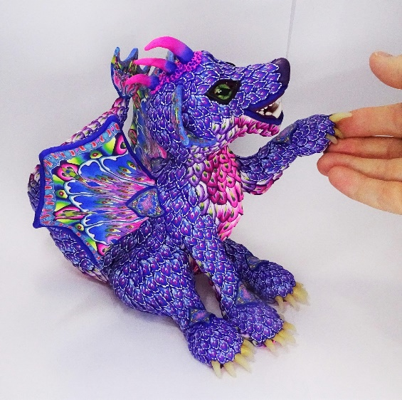

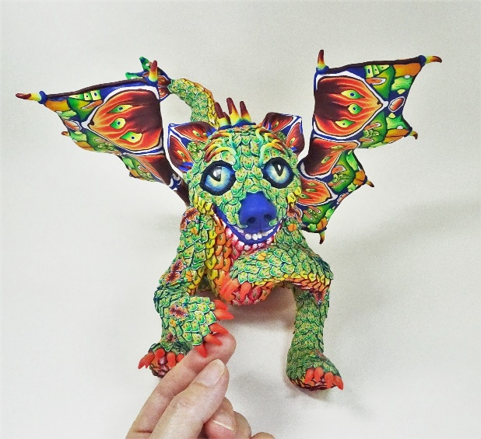

I grew up in a household with 3 teachers, so it was no surprise really, after a career in training within offices, that I started teaching polymer clay too. It is a joy to teach a subject that you are passionate about, and I have been teaching for nearly 10 years now. Until recently I have had to be very local as I was unable to travel far, but when my wonderful husband bought me a camera and editing app at the end of last year, the world of YouTube tutorials opened up.
As well as continuing to do the simple technique tutorials for free on YouTube, I am planning on sharing my more complex techniques in new paid for Video tutorials. These will cover a whole range of techniques, subject matters and designs, sharing tips and techniques I have learnt on my own polymer journey.
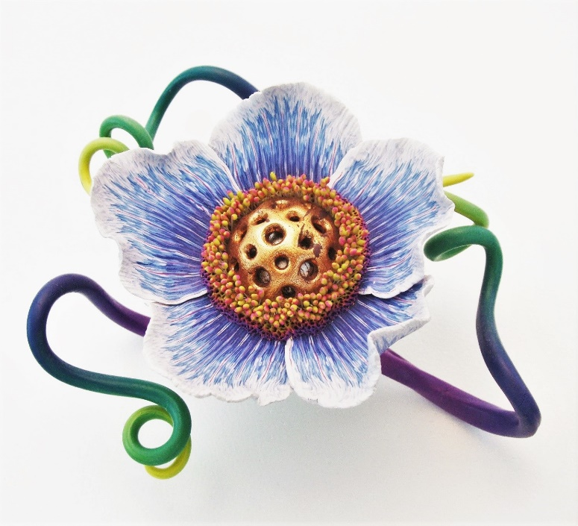

Every day I learn something new about our wonderful medium, as I see how far I can push both it, and myself to create a new technique, work or design. I am looking forward to seeing where this creative path takes me next.

Links:
Website: http://www.fionaabel-smith.co.uk/
Facebook: https://www.facebook.com/fiona.abelsmith
Etsy: https://www.etsy.com/uk/shop/PolyOriginals?
YouTube: https://www.youtube.com/channel/UCfOtQFNlHAH1n9-D82P1l3w
Instagram: https://www.instagram.com/fionaabelsmith.artist/

